Consultant Time and Attendance Manual

(Insert Logo)

Timesheet Submittal Process

Login → Click on timesheet tab → Enter time → Enter Expense if applicable → Enter Leave hours if applicable → Enter Notes / Milestones → Save Time
- Log into Avionté: https://BUILDNAME.myavionte.com/staff/login.aspx
* If this is your first time entering time in Avionté, you will be receiving an email from the email address notifications@myavionte.com with login instructions (as seen below). If you are a returning contractor, please use the same login credentials.
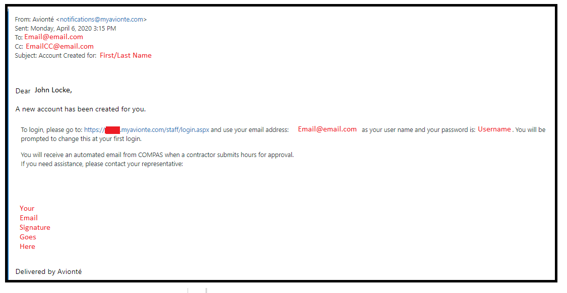
- Once logged in, you will land on your MyAvionté page which will include your current positions.
- Click 'View Timesheet' to begin entering time.
  - Use the arrows to the top right or left of the page to filter through weeks.
  - Enter the Time in and Time out for each day you worked.
    - Scroll to select a time or simply type the number and the scroll will default to that number. For example, if I type '8' as my start time, the drop down will move to 8 am.
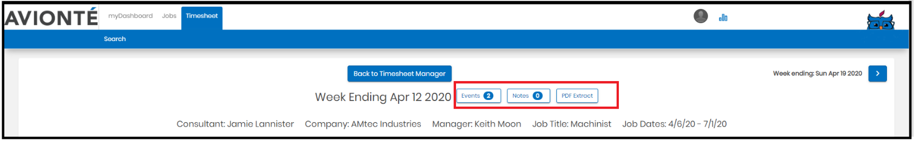
    - Enter your notes, leave hours, and expenses using the corresponding boxes.

- Once you have submitted all time for the week, select “Save & Submit time” as demonstrated in the below image.
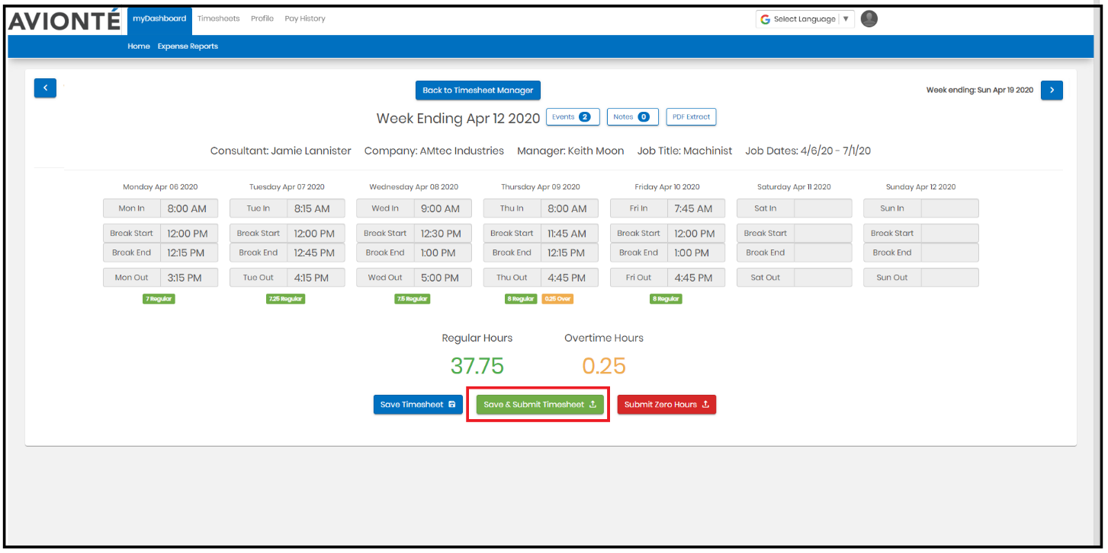
- A pop-up will then appear to confirm the time and enter notes.
  - Click "Set as Default" if you work the same hours every week. Next time you login to Avionté to submit your time, you can select Apply Default and all the hours for the week will autofill the timesheet.
- Click Submit Timesheet to submit your timesheet for approval.

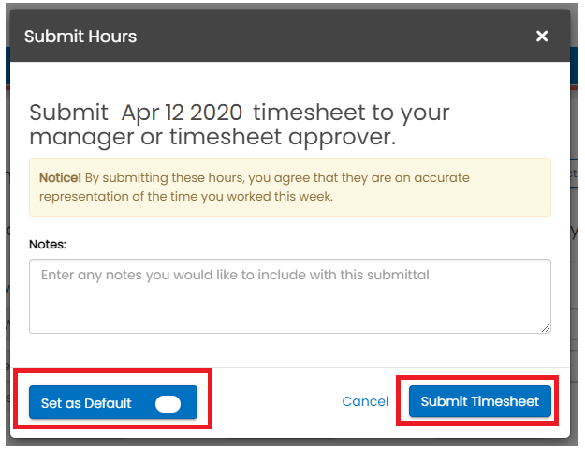

Enter hours for an Employee/Talent that works overnight

Example:
John Locke works 3:30 PM (Friday) to 12:30 AM (Saturday)
- To have the 30 minutes counted for Friday
  - Enter 3:30 PM (start) and 12:30 AM (end)
    - Enter time on Friday

- To have the 30 minutes counted for Saturday
  - Enter 3:30 PM (start) and 12:00 AM (end)
    - Enter time on Friday
  - Enter 12:00 AM (start) and 12:30 AM (end)
    - Enter time on Saturday

