Manager Time and Attendance Manual

(Insert Logo)

Timesheet Approval Process
Login → Click on timesheet tab → View Time sheet awaiting approval → Approve/Reject Timesheet
- Log into Avionté: https://BUILDNAME.myavionte.com/staff/login.aspx
* If this is your first time in Avionté, you will be receiving an email from the email address notifications@myavionte.com with login instructions (as seen below). If you are a returning manager, please use the same login credentials.
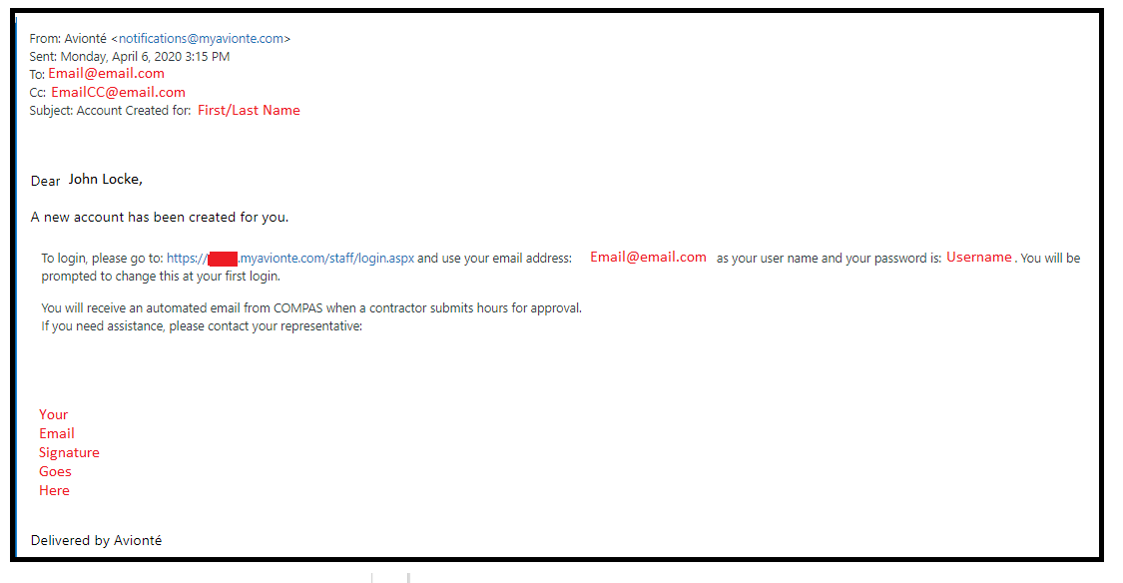

- Once logged in, you will land on your MyAvionté page. From here, the Manager Overview Widget will include Timesheets awaiting approval, requisitions that are currently pending, and active contracts.
  - Click on the number next to 'Your Timesheets waiting for approval' to be brought to your timesheet list.
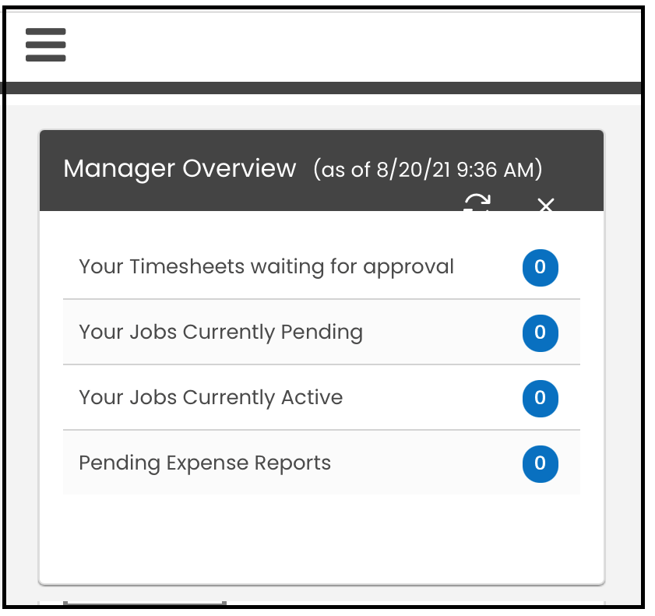

- Click the Timesheet Tab, you can view all timesheets awaiting approval.
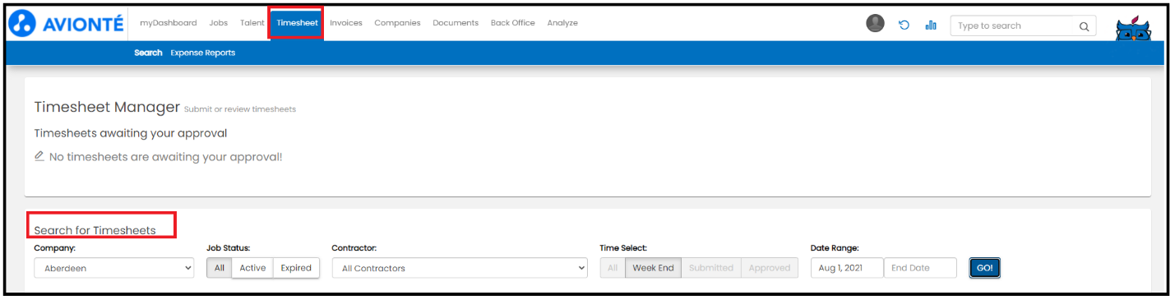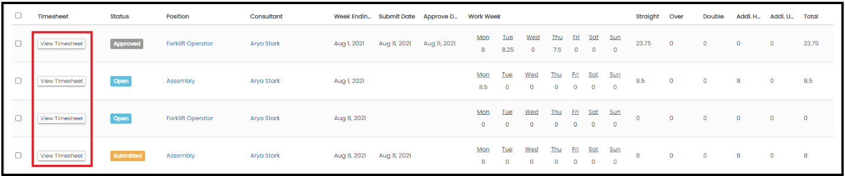

- In approving time, Managers can either Approve or Reject time. If time is rejected, the consultant will receive an email to resubmit the timesheet
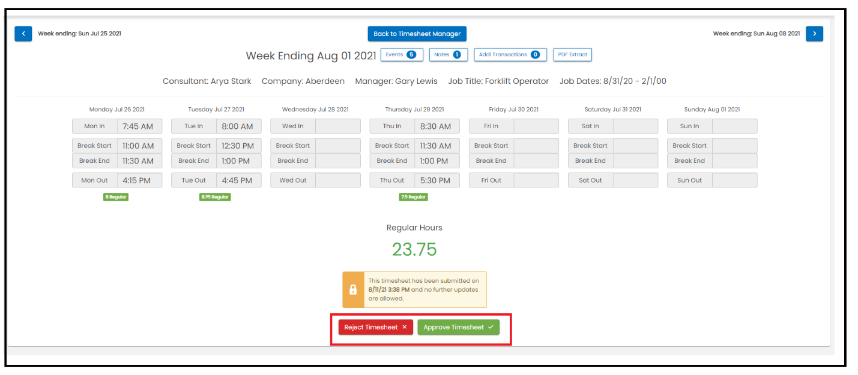

- Timesheet can also be accepted or rejected through the email that is received when the consultant submits time.
